Title: | NV-Memory
References: | Software Requirement Specification –  Non-Volatile Memory Handling in the Common Framework
Distribution | Software Archive
Author MIMS Heiko Kresse Date: 2005-09-05

Approved see Review Document

Remarks:

Contents

1 Introduction 4
2 Data Sheet 5
3 Basic Requirements 6
4 Analysis 7
4.1 Error Sources 7
4.2 Protocol 8
4.2.1 Write Operation 8
4.2.1.1 Communication Error 8
4.2.1.2 Reset Error 11
4.2.2 Read Operation 11
4.2.2.1 Communication Error 12
4.2.2.2 Reset Error 13
4.2.3 Conclusion 13
4.3 Segmentation 14
4.3.1 Communication Errors 15
4.3.2 Reset Error 15
4.3.3 Data Consistence 16
4.4 Multiple Errors 16
4.5 Timing 17
4.5.1 I²C-Bus via interrupt or polling 17
4.5.2 Background-Saving 18
4.6 Ram-Page 18
5 Static Modeling 20
5.1 NV_MEM 20
5.1.1 Methods 20
5.1.2 Initialize() 22
5.2 RAM-Page 22
5.3 I2C-Handler 22
5.4 Chip-Handler / SingleI²C-EEPROM-Handler 23
5.4.1 Initialize() 23
5.4.2 WriteData() 24
5.4.3 ReadData() 24
5.4.4 segTable 25
5.5 NV-Service/NV-Service_UHTE 26
5.5.1 Initialize() 26
5.5.2 PageIsValid(), SetPageValid(), SetPageInvalid() 27
5.5.3 DeviceISDAlibrated() / SetDeviceCalibrated() / ClearDeviceCalibrated() 27
5.5.4 GetWriteCnt() 27
5.5.5 GetData() / WriteData() 27
5.6 Storage Handler 28
5.6.1 Initialize() 28
5.6.2 Execute(), TriggerSave(), TriggerCheck(), GetState() 28
5.6.3 Load() 29
5.6.4 CheckNvStorage(), CheckAndRepair() 30
5.6.5 SaveStorage() 30
6 Revision Chart 30

Introduction
This document describes the software design for the UHTE Non-Volatile-Storage-Handler based on the common framework nv-memory handler. The Non-Volatile-Storage-Handler is an implementation of the Class NV-MEM defined by the “COMMON FRAMEWORK”. In the document nv-mem is used as shortcut for the class NV-MEM. The design consist of more then one class, all classes are collect in the nv-handler. NV-MEM is a part of the nv-handler.
The software is designed in accordance to the idea of reuse. That means to create an nv-handler fulfilling most requirements of the different device families. It should be used without intensive modifications, moreover the design and documentation should allow developers to replace or add parts of the nv-handler in an easy way.

Important!
The nv-handler main objectives are
- Cope with a low power environment with less computing-power
- Handle EEPROM-Chips via one I²C-Bus
- Suppressing error-sources, detecting multiple errors and repair single errors.

A proper knowledge of I²C-Bus and EEPROM-chips is presumed for reading this document. It is also necessary to read Software Requirement Specification – Non-Volatile Memory Handling in the Common Framework.

Data Sheet

This chapter gives an overview about all important facts of the subsystem. It can be used by a developer who would like to reuse this subsystem.

Category | Item | Description
Development | Version / Status | 1.0 / implemented; module tested; lint level 3 free
Development | Known Bugs | None
Development | Planned Improvements | None
HW-Platform | Type | M16/28
HW-Platform | Clocking | 1.8432 MHz
SW-Development Environment | Compiler | IAR M16C/C++ Compiler Version 2.12E
SW-Development Environment | Operating System | EmbOS for M16C Version 3.20d
SW-Development Environment | Code-Generation Tool | None
Required Resources | Operating System | The execute-method must be scheduled every 100ms.  Call from low prior task, because the execution-time could be greater than 1s!
Required Resources | HW | None
Required Resources | RAM | 206 + 30 * number of segments + (number of sements+7)/8
Required Resources | NVRAM | 32 * (number of segments+1) * 2
Required Resources | ROM | 4328
Required Resources | Execution Time | some seconds in background
Required Resources | Special HW | I²C-Bus Multimaster M16C, serial FRAM or EEPROM via I²C-Bus with 16-Bit addressing and pages of >=32byte
Required Resources | Subsystems
Required Resources | Data Objects
Standards | Safety | This subsystem has to fulfil the safety standard SIL level 2.
Standards | Other
Documentation | Requirements | Software Requirement Specification –  Non-Volatile Memory Handling in the Common Framework
Documentation | Public Interface Description | nv_mem.h
Documentation | Test Specification | ModuleTest see code

Basic Requirements
Basic requirements for UHTE (2wire HART-device) based on the documents named before:
- In spite of a bus clock less than 2MHz, the application must not be influenced! HART and HMI should not be influenced. (Related to UHTE)
- The application, HART and HMI should not wait longer than 5ms, regularly 2ms, for access to nv-data. (Related to UHTE)
- Single faults should be recognized and repaired. (Basic requirement)
- Double (or even better multiple) errors should be recognized. (Basic requirement)
- Consider the possibilities of the µCs internal FLASH. (Related to UHTE)
- The design must use information-hiding and strict separation of responsibilities. (Basic Software requirement)
- It should be possible to define different areas, which are treated differently e.g. the data are stored in separate nv-chips. (Software Requirement Spec. Non Volatile Memory, also Framework description)
- It must be possible to replace the EEPROM by FRAM. (Related to BUI)

Analysis
This chapter shows the error, timing and resource analysis and conclusions. The Design decisions for the Storage-Handler and for the Chip-Handler based on this analysis, so it is important to now them for design review.

Error Sources
Communication
The exact error rate is unknown; we suppose it is much better than 1 error bit per 10000 transferred bit. Nevertheless an error could occur in every situation, a proper analysis must be done.

Reset
It is the main error source. During commissioning usually the supply is not guaranteed. During connecting the device the supply is active and this leads to repeated power on resets. A lousy connection could also lead to a power lost in the very moment the data are stored.

Defect RAM and NOVRAM
Very seldom, nevertheless it should be detected.

Corrupted Bits (RAM and NOVRAM)
Very seldom, nevertheless it should be detected.

Protocol
The analysis is done in context of the two used I²C-Bus block transfers. First the simple write-operation and second the combined-operation.

Write Operation
Next figure shows the bus signals during a write operation. SCL is the clock signal and SDA is the data-signal of the I²C-Bus. (Refer Philips I²C-Bus protocol description) The protocol is fragmented; each fragment has a char for identification and a short description what happens inside.

Figure 4.1
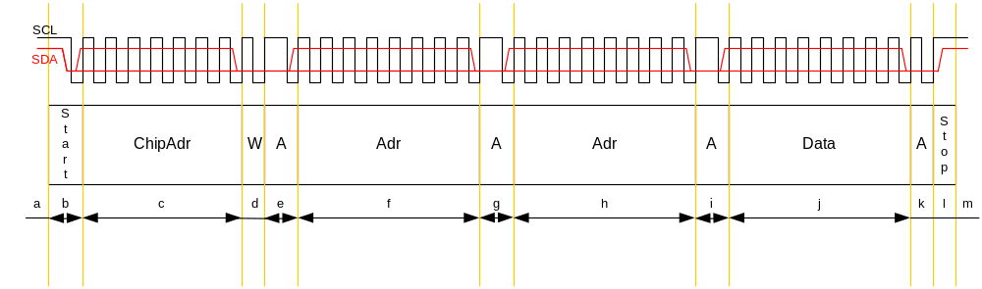

Communication Error
A single error on SDA or SCL leads one of three possible events:
- A start condition is detected inside the fragment
- A stop condition is detected inside the fragment
- Wrong data

Table 4.1
Fragment | Effect | Recognition / Repair
a, m | No effect – each START resets an I²C-Bus-statemachine  No effect – the following START override the STOP, respectively a STOP after a STOP is only a STOP  No effect – will be ignored | -  -  -
b | -  next byte without ACK  next byte without ACK | -  no ACK / retry  no ACK / retry
c | No ACK – restart I²C state machine  No ACK – I²C state machine stops  - no ACK  - ACK from an other chip | No ACK / retry  No ACK / retry  - no ACK / retry  - see “chip address error”
d | Like c  Like c  Read operation instead of write → no ACK; data will not be corrupted | No ACK / retry  No ACK / retry  No ACK / retry
e,g,i,k | Not possible as single error, because the slave pulls SDA down, a missing clock on SCL leads to an error in f,h,j,l | -
f,h | Like c  Like c  Writing to wrong address | No ACK / retry  No ACK / retry  See “address error”
j | Like c  In case more than on byte are written, the STOP leads to no more ACK. The STOP starts the burning process, the last byte might be corrupted.  Wrong data are written | No ACK / retry  NO ACK / retry, consider burning time  Verify / retry
l | Data will not be stored, without double error no other effect  -  Data will not be stored, without double error no other effect | Verify / retry  -  Verify / retry

Chip Address Error (not possible for UHTE)
In multiple nv-chip designs is it possible to write into the wrong chip. This case could not be recognized by the bus protocol. A byte-verify could detect this error, if the data to be written and the EERPOM data are different in one byte at least.
A repair includes two actions. First repeat the write operation, second repair in all other nv-chips the overwritten data. This is necessary, because except for two-chip designs it is impossible to determine the chip written into. For the second step it is necessary to know what must be stored at the corrupted location.
Proposal:
Use separate busses for each nv-chip or use the nv-chip write-protection. The write-protection must protect the whole address range.

Address Error
This case could not be recognized by the bus protocol. A byte-verify could detect this error, if the data to be written and the EERPOM data are different in one byte at least.
A repair includes two actions. First repeat the write operation, second repair in all other nv-chips the overwritten data. The problem is to determine the location of overwritten data, because it is not possible to get the write pointer.
Proposal:
- A segmentation of the nv-memory into segments of 32 bytes (write buffer length=32)
- Each segment has a 16-Bit CRC
With the CRC it should be possible to find every corrupted segment, except the incorrect address is 32-byte-aligned.
→ The complete segment address (nv-chip +first byte) is included in the CRC calculation. Considering the address guarantee different CRC for same data at different location.
- A backup of every segment is necessary to repair the corrupted segments.
An address error leads normally to two corrupted segments, which are directly neighbors. If the direct neighbor is the backup segment, the segments could not be repaired.
- Beware of direct neighborhood of a segment and its backup segment.
- After recognition of an address error, the corrupted segments should be found and repaired immediately.

Reset Error
Table 4.2
Fragment | Effect | Recognition / Repair
a,b,c,d,f,h,j,l,m | The START condition of the first frame after a reset stops the write operation.  An EEPROM will not burn the received data.  A FRAM will have incomplete written data | Incomplete data will be found by segmentation + CRC / repair with backup  Without the knowledge of the last state before reset, it is necessary to check all segments.
e,g,i,k | The START condition of the first frame after a reset will be overwritten by the ACK of the SLAVE, thus at least one byte will be overwritten (i, k only). | Same as before.  Better solution:  Send two start conditions after Reset. The additional start condition generates a CLK that end the ACK of the slave.

Read Operation
Next figure shows the bus signals during a read operation. SCL is the clock signal and SDA is the data-signal of the I²C-Bus. (Refer Philips I²C-Bus protocol description) The protocol is fragmented; each fragment has a char for identification and a short description what happens inside.

Figure 4.2
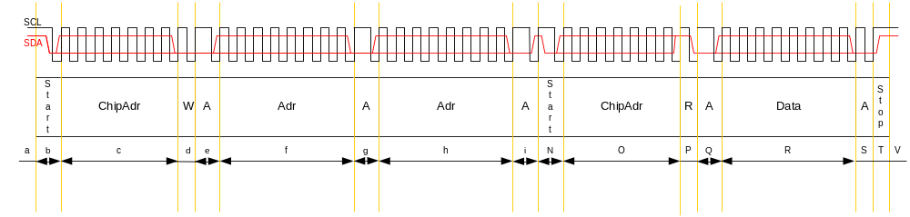

Communication Error
A single error on SDA or SCL leads one of three possible events:
- A start condition is detected inside the fragment
- A stop condition is detected inside the fragment
- Wrong data

Table 4.3
Fragment | Effect | Recognition / Repair
a-i | The read operation is exactly the same as write operation until fragment N.
N | -  Without a new START condition the following data will be ignored.  Missing the START condition overwrite two segments, because 33 byte (0xFF) will be written. The chip address is the first byte, the master generate the CLK for the next 32 Byte. | -  CRC-error / retry  CRC-error, all received bytes are 0xFF/ repair the active segment with backup. (And the next one; for Chips with only 32-byte write buffer only one segment is damaged.)
O | No ACK  No ACK  No ACK or data from wrong nv-chip | No ACK / retry  No ACK / retry  No ACK or CRC / retry
P | No ACK  No ACK  The actual segment will be overwritten with FF | No ACK / retry  No ACK / retry  CRC-error, all received bytes are 0xFF / repair the active segment with backup. (
Q,S | Reset all I²C-slaves, Master generates CLK, FF is not a possible nv-chip address, so nothing happens  Without new START nothing happens.  NO ACK | CRC-error / retry  CRC-error / retry  No ACK / retry
R | Reset all I²C-slaves, Master generates CLK, FF is not a possible nv-chip address, so nothing happens  Without new START nothing happens.  CRC error | CRC-error / retry  CRC-error / retry  CRC-error / retry
T, V | Nothing happens  Nothing happens  START of the next frame stops slaves reading mode. | -  -  -

Reset Error
Table 4.4
Fragment | Effect | Recognition / Repair
a,b,c,d,f,h | The START condition of the first frame after a reset stops the write operation. | No data was written → no error happens.
e,g,i | The START condition of the first frame after a reset will be overwritten by the ACK of the SLAVE, thus at least one byte will be overwritten (i only). | Send two start conditions after Reset. The additional start condition generates a CLK that end the ACK of the slave.
S,T,V | No effect for single error | -
N,O,P | No effect because START resets the I²C-state machine | -
Q | The START condition of the first frame after a reset will be overwritten by the ACK of the SLAVE, thus at least one byte will be overwritten. | Send two start conditions after Reset. The additional start condition generates a CLK that end the ACK of the slave.
R | The slave is able to pull down SDA for 8 cycles START conditions will be overwritten. | Send 9 start conditions after Reset.

Conclusion
- Retry read or write operation if the slave acknowledge is missing
- The nv-memory is fragmented into 32-byte segments. A read or write operation access always a complete segment. (For EEPROM with 64-byte write buffers or FRAM, 64-byte segments are recommended.)
- Each segment has a 2-byte CRC and 30-byte data
- The CRC goes over the complete segment address + the 30 data bytes.
- Read operations are validated by CRC
- Write operations are validated by a complete (data + CRC) byte verify.
- Write a segment only if at least one byte is different to the data inside the nv-memory. Only this guarantees that an address error will be recognized by byte verify.
- In case of an address error all segments must be validated by their CRC
- Each segment has a backup segment, so it could be repaired in any case.
- Beware of direct neighborhood of segment and its backup; because address errors usually overwrite two neighboring segments.
- After recognition an address error, the corrupted segments should be found and repaired immediately.

Segmentation
Chapter 4.2 has as one conclusion the requirement to organize the nv-storage into segments. This chapter analyzes if the segmentation solve all problems or if new problems pop up.
The nv-memory is fragmented into 32-byte segments. A read or write operation access always a complete segment. And each segment has a backup segment, so it could be repaired in any case.
Figure 4.3
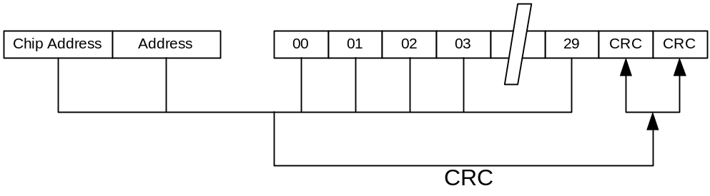
The sum of all segments is called the Main-Page; the sum of their backup segments is called the Backup-Page.

Figure 4.4
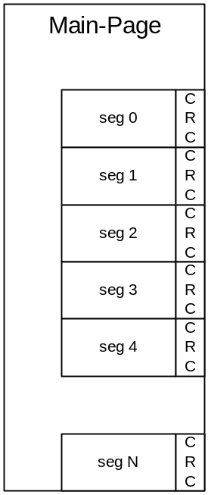 | 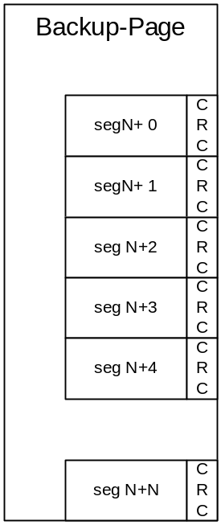

Communication Errors
Data Error
Recognized by verify. It will be repaired be rewriting the segment.

Address Error
In most address-error situations it is not possible to determine which segments are corrupted before the whole storage is analyzed. Thus it is possible that both pages are corrupted (e.g. single-chip-design). This situation is very dangerous because a power down could damage the device. Obviously the time both pages are potentially damaged must be as short as possible.
The fastest action is to stop the actual operation and to store the complete main-page. That is possible, because this error could only happen after the nv-data are loaded into ram.

Reset Error
A reset during one segment write will be recognized by a CRC-error. The page the corrupted segment belongs to must completely repaired. That means copy the faultless page into the damaged page.
Comparing both pages will recognize a reset between writing main-page and writing backup-page. If both OK but different, the main-page must be copied into the backup-page.
A reset between two segments of the main-page is a problem. After the reset both pages are OK but different, and the not consistent main-page will be copied into backup. To solve this problem each page has a service segment. Inside this service segment is a valid flag. Writing a page starts with writing the service segment with a cleared valid flag. If the page is stored without an error the service-segment will be stored again, with the valid flag set. After a reset the service segments will be loaded. If one page is not valid it will be overwritten with the page valid.

Data Consistence
Information hiding and separation of responsibility, here the separation of data handling and nv-memory-handling, have many advantages but there is at least one problem:
The nv-handler does not know anything about the data structures to be stored.

That means single data or structures are spread over more than one segment. For some circumstances it is not good or forbidden, to repair only single segments. The nv-handler is not able to decide if it is allowed to repair single segments or not. Thus the nv-handler repairs always a complete page.
→ It is not allowed to repair two damaged pages by merging not damaged segments!!!!

It is important to have at least one valid page in every situation.
- It is not allowed to store the segments alternating between main-page and backup-page.
- It is necessary to store first the complete main-page. If no error occurs the complete backup-page will be stored next. Complete means all segments different to the stored data.
→ Save or repair one page in a time

The chance that an address-error during an access to the main-page will overwrite a segment in the backup-page must be less as possible. That means main and backup segments must not be mixed inside the address-range. Because there are two pages, the address of a main-segment and the corresponding backup-segment differs at least in the MSB. It might be good if the address is also different in the lower significant part. But there is no real advantage, because pages will be repaired completely.

Multiple Errors
Two or more errors could overcome the error-protection. Nevertheless the damaged data inside the nonvolatile memory must be recognized, to prevent the device from undefined action.
The byte-compare after writing is able to detect every error-combination. But the read operation could only protected by a checksum. Reading and comparing the checksum, too, will detect detection of errors after a reset. So it is possible that some error-combinations could not be detected, because they have a legal checksum. To reduce this risk to a minimum a 16-Bit CRC will be used to protect each segment.
The worst error-combination for reading is an error in the address, missing the second start-condition, writing FF into two segments, getting the stop condition and after all a reset occurs. In this case parts of two segments are overwritten with FF. The CRC should be able to detect this in nearly every situation.
The worst error-combination for writing is an error in the address and a reset after the writing has finished. In worst-case two segments are overwritten. In this case every data-combination is possible. That is a problem for the first segment, because the checksum will be overwritten to. So the chance for a legal checksum is 1/65536.
As a conclusion there is no absolute protection against combined errors. But the combinations that overcome the protection of NV-MEM are very strange. Thus the error protection needs no enhancements for multiple errors.

Timing

I²C-Bus via interrupt or polling
The communication-speed depends on the bus capacity and the pull-up resistance. The capacity is given by the typical input-capacity of CMOS so we have 10-20pf. Assuming that the speed will be set to the possible maximum for the given resistor, the power-consumption (energy) depends only on the amount of data that is transferred over the bus. But the current that must be provided increases linear to the communication speed.
If we choose 100Kohm for pull-up 30µA for SDA and also for SCL must be provided. For a proper function the SCL-signal must be about 80% of the supply-voltage for the half period time of the maximum I²C-bus frequency. Together with the given delay-time to reach 80% the maximum speed for UHTE are

= 60,8KHz
The nv-chips are usually able to work with 400KHz I²C-Bus speed so 100KHz should be possible without problems. Actually 75KHz are used, thus transfer of one byte (9Bit) needs 120µs. For 1,8MHz it is not possible to write an interrupt function with less than 30µs. That means the transfer via interrupt cost 25% of the available computing time. The disadvantage is, that interrupts interrupt all tasks, also the process calculation or the sensor-interface and influence their real time behaviour. In fact they do not reach their real-time requirements anymore.
Conclusion:
Polling waste 75% computing-time but if it is done in the background-task, it doesn’t influence higher prior tasks. So the UHTE-project I²C-Bus-handler uses polling.

Background-Saving
Writing one segment means reading segment, writing and reading again. So 96byte must be transferred plus 12Byte overhead plus some computing (e.g. checksum) → 15ms.
It could happen, that an object lies over the boarder of two segments, then two segments must be stored in the main-page and in the backup-page. All together its possible that 4 segments must be written to store one object. The minimum time for this is 60ms. Considering that the background task could run for 30ms in a 100ms-slot, it cost between 130ms and 215ms. The Layer 7 of HART is scheduled every 100ms together with 215ms saving time in worst case, the maximum response time of HART could not be guaranteed, and so we have to save in background.

Ram-Page
As described in “4.3.2” the EEPROM – access must be done in background. The usual solution for this problem is a shadow of the EEPROM inside RAM. Every access from the application to the NOVRAM will be done to the RAM.
Requirements:
- The UHTE project is cost sensitive only 4Kbyte RAM are available, non-volatile data must be stored only once in RAM.
→ The non-volatile data are stored directly into the Ram-Page (Ram-Shadow). That means no double buffering for non-volatile data!

- To save Time only changed data should be stored.
    - The Ram-Page is fragmented into segments like the Main-Page. NOVRAM-operations handle always a whole segment, so a dirty-flag for each segment is enough to save maximum time.

- The NV-handler is responsible for consistence of NOVRAM and RAM-Shadow.
→ Load MAIN-Page into the RAM-Shadow called Ram-Page
→ Save Ram-page segments marked as “dirty” 5 seconds after the safe-flag is set
→ Check Ram-page, Main-page and Backup-page from time to time

- Fast read access for the application must be guaranteed.
→ A direct read access to the application non-volatile data must be possible.
→ The application defines const-variables sharing the same address-range as the Ram-Page.

- Information hiding → no knowledge of the structures to be stored
→ The linker will do the sharing of the address-range. (Overlaying linker segments)
- The non-volatile data and the NOVRAM-shadow will be accessed from different tasks at the “same time”.
→ The application uses resource semaphores to cope concurrency problems, e.g. each subsystem uses a resource semaphore for its nv-data. → The ram-page does not need an own semaphore.
→ The nv-handler stores all dirty marked segments until no more segments are dirty.
→ The dirty-flag handling guarantee that not dirty-flag get lost.
Writing into the ram-page: first write data, than set dirty
Copy from ram-page into nv-chip: clear dirty, write data

Bebecause the page will be written until all dirty-flags are cleared, the data will be temporally inconsistent, but in the end the page will be stored completely.

→ The application must not work during the load operation! Or the application is stable against temporally inconsistent data.

Figure 4.5
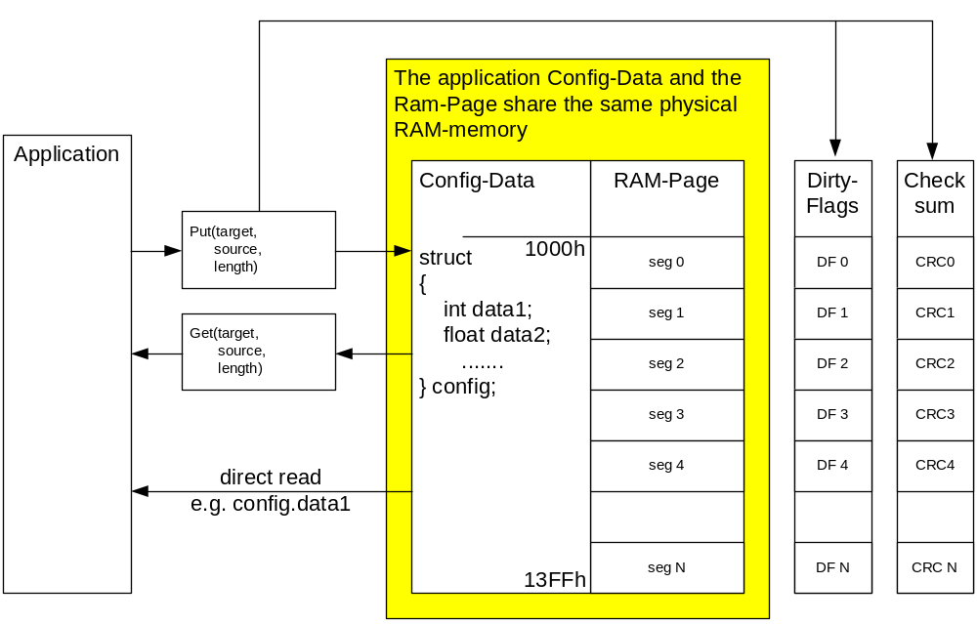

Static Modeling
The figure below shows the nv-handler static class design.
Figure 5.1
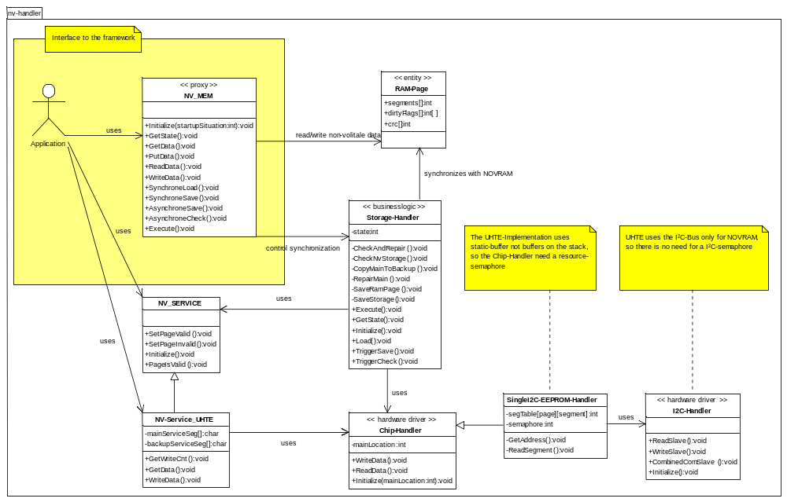

NV_MEM
NV-MEM is the visible class of the nv-handler-subsystem. It maps the functionality needed by framework to the internal structure of the nv-handler. The interface defined by the framework supports different possible nv-handler solutions, thus not all functions must be supported by a special implementation of NV-MEM. This implementation does not support the methods WriteData() and ReadData().

Methods
Initialize(): Initializes the software and hardware used for the non volatile handling.
GetState(): Returns the actual state of the nv-handler.
PutData(): Write data into the rampage. The data is not stored in the nonvolatile memory.
GetData(): Read data from the rampage, not from the nonvolatile memory.
SynchroneLoad(): The complete main-page will be loaded into the ram-page. If this is done the function ends.
AsynchroneSave(): The complete ram-page will be written into the main-page and the backup-page. The action starts in background some time after the function returns.
SynchroneSave(): Same as AsynchroneSave() but the action will be done inside the function.
AsynchroneCheck(): Main- and backup-page will be checked in background some time after the function returns.

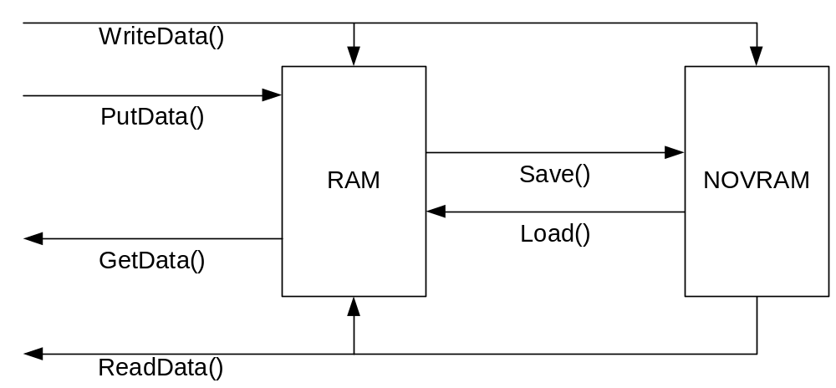

Not supported:
ReadData(): Read data out of the nonvolatile memory. The data will also be copied into the ram-page.
WriteData(): Write data to the ram-page and to the nonvolatile memory.

Initialize()
The following sequent diagram shows how the initialize-method works. It calls the initialize-methods of the chip-handler, the nv-service and the storage-handler and maps their results to the nv-mem return-codes.
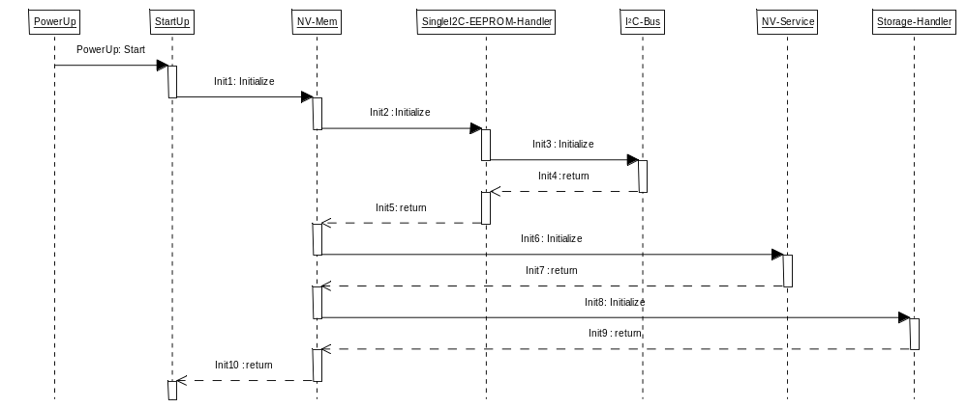

RAM-Page
The ram-page is array of segments, for each segment exist one dirty-flag. Chapter Ram-Page explains the idea of the ram-page.
As shown in Figure 4.5 data structures that should be nonvolatile are mapped into the ram-page. To do this the structure must be defined a own memory-segment.

#pragma dataseg=NEAR NV_DATA
const NEAR __no_init T_TEST cuData;
#pragma dataseg=default

The defined segment will be put inside the ram-page via the linker-command-file.

-Z@(NEAR)RAMPAGE=1040-13FF
-Z@(NEAR)NV_DATA=1040-104E

I2C-Handler
The I²C-handler offers functions for I²C communication. (see Philips I²C-Bus specification Version 2.1)

Chip-Handler / SingleI²C-EEPROM-Handler
There are some reasons to separate the handling of a single segment from the storage handler:
- It is a function that cold be separated; it has a clear responsibility and only a small interface to the storage-handler. → Simplifying code → simplifying test → simplifying maintenance
- It encapsulates hardware related functionality. If the I²C-bus will be replaced by SPI than only the chip handler has to be adapted. Also if EEPROMs with smaller write-buffers will be used, only the chip-handler must be adapted.
- Additional functionality like NV-Service could reuse the segment functionality.

The abstract class Chip-Handler defines methods to read and write segments. SingleI2C-EEPROM-Handler, a child of “Chip-handler”, implements the segment-functions for EEPROMs with a minimum write-buffer of 32-byte connected to a single I²C-Bus.

The abstract class “Chip-Handler” defines the interface used by NV_MEM and Storage-Handler.
The singleton class “SingleI2C-EEPROM-Handler” defines a chip handler that could handle up to eight EEPROM-chips via one single I²C-Bus, as long as the write-buffer of the EEPROM-chip (or FRAM) is greater or equal than 32-byte and as long as the burning-time is less than 5ms.
The nv-storage will be configured via the segment-tables. Usually the mainSegTable contain the management information for the segments of the main-page. For some data the location of the main-page could change, so it is necessary to set the actual location of the main-page for this data.
To support multitasking the chip-handler uses a resource-semaphore that will be requested for data-request.

Initialize()
TUSIGN16 Initialize_CHIPHANDLER(TUSIGN8 mainLocation);
This method initializes the resource semaphore and set the chip-handler state to initialized. The location of the main-page for segments without a fixed definition, will be defined only be initialization with the parameter “mainLocation”.

WriteData()
TUSIGN16 WriteData_CHIPHANDLER(TUSIGN8 page, TUSIGN8 segNum, const void __data16* ptrSource);

The segment at the address (ram) “ptrSource” with the number “segNum” will be written into the page “page” of the non-volatile memory. Multitasking is supported, that means the resource semaphore will be requested before the I²C-Handler-call and will be released afterwards.
The chip-handler does not know the ram-page, so it is not possible to generate the ram-address bases on the ram-page and the segment-number.

Operation
- get the nv-chip address and the data-address
- read the addressed segment out of the nv-chip
- compare it with the data at the address “ptrSource”
- go on with operation if they are not the same
- copy data into a write buffer for the I²C-handler
- calculate checksum over address and data
- write the segment
- wait 5ms
- read the segment and compare it with the buffer
- if data are equal the writing was successful

ReadData()
TUSIGN16 ReadData_CHIPHANDLER(TUSIGN8 page, TUSIGN8 segNum, void __data16* ptrTarget);

The method reads the segment with the number “segNum” out of page “page” (non-volatile memory) to the ram at the address “ptrTarget”. Multitasking is supported, that means the resource semaphore will be requested before the I²C-Handler-call and will be released afterwards.
The chip-handler does not know the ram-page, so it is not possible to generate the ram-address bases on the ram-page and the segment-number.

Operation
- get the nv-chip address and the data-address
- read the addressed segment out of the nv-chip
- calculate the checksum and compare it with the loaded checksum
- if the checksums are equal the reading was successful

segTable
The segment-table maps the segments of the rampage to the nv-chip(s) memory.
The following figure shows not the implementation for UHTE! It shows a possible solution for a two-chip-design, to give a better explanation of the segment-table concept. The area-behaviour is realised by the segment mapping.
Figure 5.2
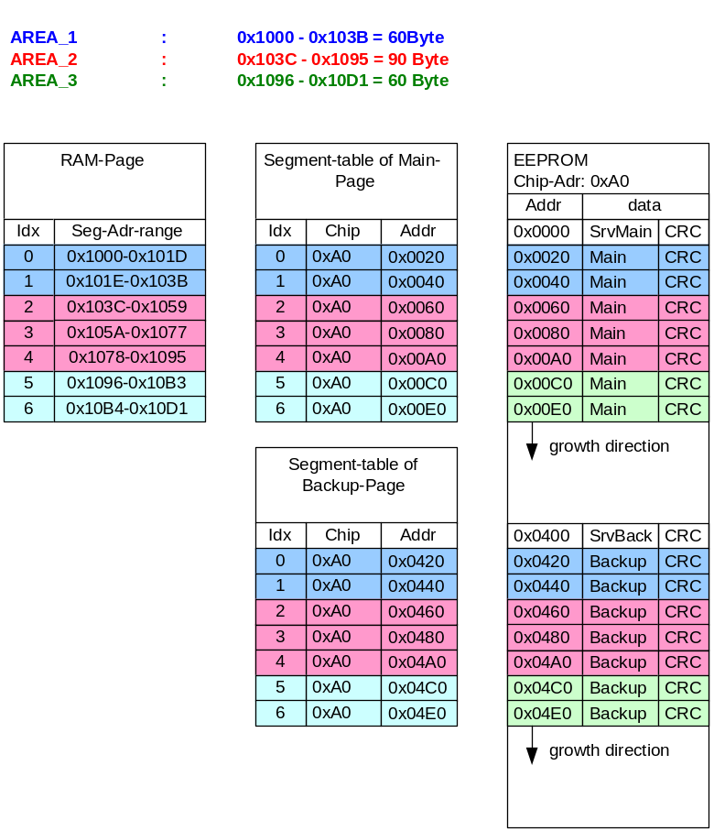
In this example (Figure 5.2) nv-buffer offers three areas. These areas will be placed via linker commands to the shown addresses inside the ram-page. The boarders of the areas lay on the boarders of ram-page- segments. The ram-page-segments are mapped via the segment-table into the storage of the nv-chip.
Obviously this mapping could be done by rules and in the first step they are not more complex than the segment-table and save rom-resources. But the segment-table is able to abstract complex rules to simple code. For example: A new release version adds some functionality that uses also nv-data. If the new release must be compatible with old nv-data-structures, then it is much easier to map the new rules to the segment-table than to realize the new rules in code.
Or another example: A new hardware-version uses two smaller EEPROMs instead of one. In this case a new segment-table is a faster way than coding new rules. And it has the advantage of easier testing, because only the context changed not the code.

NV-Service/NV-Service_UHTE
As described in the analysis of Reset-Errors and their influence to the segmentation, it is necessary to store a Flag non-volatile for each page that shows if write access is actually active for one page. From beginning of the write-access until the end the page is not valid. The valid-flag will be stored in a special-segment, the service-segment; each page owns one service-segment. If a reset occurs between the writing of two segments, all segments are OK but the application-data could be a mismatch of old and new data. The valid flag indicate this possible mismatch. If after reset one page is not valid, it will be overwritten with the page valid.
Only 4 byte of 30byte in one segment are used for the valid-flag. The UHTE-Implementation uses these bytes for a write-access-counter, a calibrated-flag and free accessible data. Free accessible data could be used by the application e.g. for a version numbering of the nv-data-structures.
Both service-segments (main-page and backup-page) have a complete shadow inside the RAM. So the nv-service-subsystem is independent from rampage and storage-handler.

Initialize()
TUSIGN16 Initialize_NVSERVICE(void);
The Initialize()-method load the service-segments out of the nv-storage into the service-shadows (RAM). If both are damaged or not readable than the nv-storage is virgin; that means it isn’t formatted. A damaged service segment will be overwritten and the valid-flag will be set to “invalid”. If writing fails, the nv-storage is defect.
As long as the calibrated-flag is set in one service-segment the device is calibrated and the calibrated-flag will be set in both service segments.
At the end of the method the system knows if the nv-storage is defect, not formatted (virgin) or formatted and not calibrated or calibrated.

PageIsValid(), SetPageValid(), SetPageInvalid()
TBOOL PageIsValid_NVSERVICE(TUSIGN8 page);
Test if the valid-flag of the page “page” is set. Returns TRUE if the page is valid.

TUSIGN16 SetPageValid_NVSERVICE(TUSIGN8 page);
Set the valid-flag of the page “page” to valid.

TUSIGN16 SetPageInvalid_NVSERVICE(TUSIGN8 page);
Set the valid-flag of the page “page” to invalid and increment the write-counter.

DeviceISDAlibrated() / SetDeviceCalibrated() / ClearDeviceCalibrated()
TBOOL DeviceISDAlibrated_NVSERVICE(void);
Returns TRUE if the calibrated-flag is set in both service-segments.

TUSIGN16 SetDeviceCalibrated_NVSERVICE(void);
Set the calibrated-flag in both service-segments.

TUSIGN16 ClearDeviceCalibrated_NVSERVICE(void);
Clear the calibrated-flag in both service-segments.

GetWriteCnt()
TUSIGN32 GetWriteCnt_NVSERVICE(TUSIGN8 page);
Returns the 32-bit write-counter of the page “page”. The counter will be incremented each time the valid-flag will be set to invalid.

GetData() / WriteData()
The application could access the unused data of the service segment via these methods. The macro-const “NVS_DATALENGTH” defines the number of bytes that are free to use.

TUSIGN16 GetData_NVSERVICE(TUSIGN8 page, TUSIGN8 length, void __data16* ptrData);
Copy “length” byte from the service-segment of page “page” to the address “ptrData”.

TUSIGN16 WriteData_NVSERVICE(TUSIGN8 page, TUSIGN8 length, const void __far*ptrData);
Copy “length” byte from the service-segment of page “page” to the address “ptrData”.

Storage Handler
The storage handler is Responsible for the synchronization between Ram-page, Main-page and Backup-page. That means it checks the main-page and the backup-page, it compares both pages and it repairs errors if possible. It loads the main-page into the rampage and it stores dirty segments of the ram-page into the main-page copies the main-page to the backup-page. Except the load-operation, the storage-handler does all functions in the background, thus the Execution-Method of the storage-handler must be scheduled from the application.

Initialize()
TUSIGN16 Initialize_STORAGE(void);
It initializes the
- State machine
- Fill the gaps of nv-data with zero. (0xFF is the value of virgin nv-storage)
- Check the nv-storage
- Repair the storage if necessary
- If nv-storage is ok, load nv-storage into the rampage. (For UHTE now all nv-data are loaded)
- Set the state machine to new state according to the error-codes

Execute(), TriggerSave(), TriggerCheck(), GetState()
void Execute_STORAGE(void);
The Execute-function handles the storage-handler state machine. The activities of some states last for more than 1s, consider this for the scheduling.

TUSIGN16 TriggerSave_STORAGE(TUSIGN16 triggerTime);
TUSIGN16 TriggerCheck_STORAGE(TUSIGN16 triggerTime);
TUSIGN16 GetState_STORAGE(void);
These functions do exactly what the name implies.

The following figure (5.3) shows the state machine.

Figure 5.3
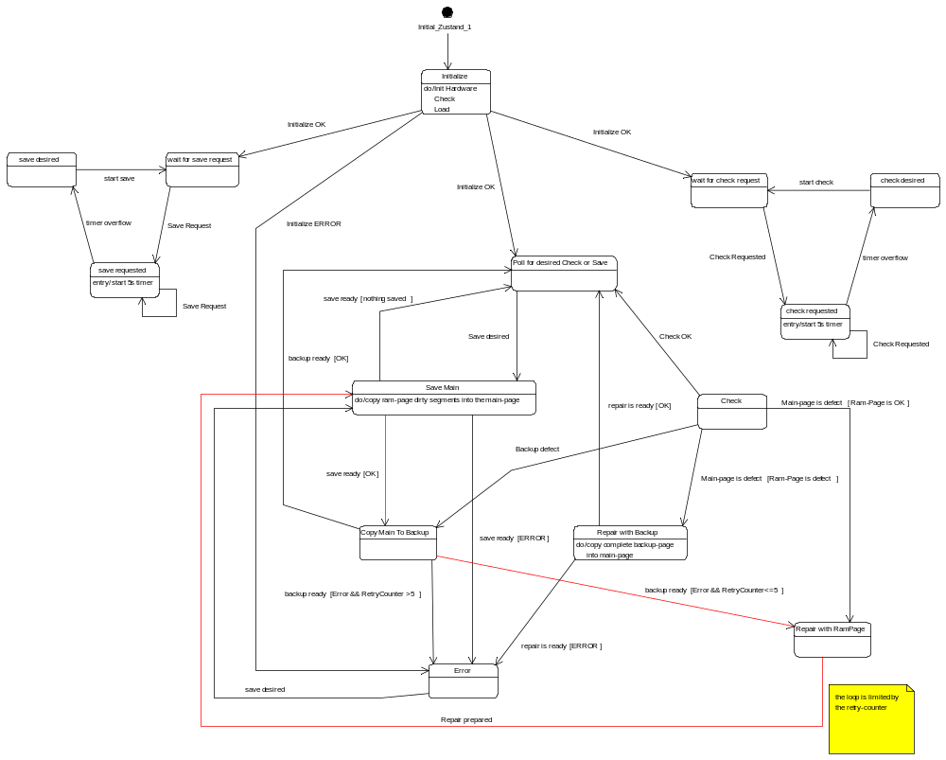

Load()
TUSIGN16 Load_STORAGE(void);
It is a very simple function; all segments will be loaded and all dirty-flags will be cleared. The call is synchronous. As long as Load() runs, the configuration is not valid, a proper function could not be guaranteed. The application-designer is responsible that load() will be called only in times a proper device-function is not necessary.
Usually factory-data will not change, so it is possible to set the current-output to a fixed current, for time data will be loaded.

CheckNvStorage(), CheckAndRepair()
TUSIGN16 CheckNvStorage(TUSIGN16 ramPageState);
The function check if
- both pages are valid; if not both not valid → defect else repair the non valid page
- check the segments of the valid pages; a damaged segment set the page state to invalid
- both pages invalid → defect
- both pages valid but not equal → declare backup as invalid

TUSIGN16 CheckAndRepair(TUSIGN16 ramPageState);
It calls CheckNvStorage() and try to repair the detected errors.
- both pages invalid → defect, repair not possible
- main-page invalid → if ram-page is valid then copy ram-page to main-page else copy backup to main.
- backup-page invalid → copy main to backup

SaveStorage()
TUSIGN16 SaveStorage(void);
First all dirty segments of the ram-page will be stored to main-page. This will be repeated until one loop ends without any segment was marked as dirty. Afterwards the main-page will be copied as whole to the backup-page.
If an error occurs while storing main-page, all segments will be set to dirty, so all segments will be stored again.
If an error occurs while storing backup-page, the reaction depends to the error. If the main could not be read, the main will be stored again by setting all dirty-flags. If the backup could not be stored, it will be tried again.

Revision Chart

Rev. | Description of Version/Changes | Primary Author)s) | Date
0.0.0 |  | Heiko Kresse | 2004-09-09
0.0.1 | adapted to changed NV-MEM definition | Heiko Kresse | 2004-09-22
1.0 | Release | Heiko Kresse | 2005-09-05

